**ENEL 476 – Electromagnetic Waves and Applications**

**Assignment #3**

**Due April 15, 2020**

**Question 1.**

A coaxial cable has a=0.5 mm, b=2.95 mm, r=2.25 and r=1.

1. Find the inductance per unit length (L) and capacitance per unit length (C).

Note: C=2/ln(b/a) and L=(/2)*ln(b/a)

1. Assume that the coaxial cable is lossless. Calculate the propagation constant () and impedance (Zo) at 10 GHz.
2. If the cable has attenuation of =1.06 Np/m and assuming the conductance per unit length (G) is zero, find the resistance per unit length (R).
3. Using L and C calculated in *part b* and R calculated in *part c*, find the value of G required for a distortionless line.

**Question 2.**

A load of ZL=40-j20  is attached to a 60  transmission line.

1. Find reflection coefficient and VSWR using transmission line formulas.
2. Verify your answer to *part a* using the Smith chart.
3. Find Zin at a distance of 0.275 from the load using the transmission line formulas.
4. Verify your answer to *part c* using the Smith chart.
5. Find the distance from the load (ZL) to Vmin and Vmax using the Smith chart.

**Video 1.**

One option for creating your video is YuJa (<http://elearn.ucalgary.ca/yuja-students/>). You are welcome to use other approaches as well. Please upload to Dropbox on D2L

Your video should walk through your solution to Question 2. Please include the following:

1. Show how you plotted zL on the Smith chart.
2. Show the constant s-circle for zL plotted in part 1 on the Smith Chart.
3. Describe how you obtain the reflection coefficient and VSWR (aka SWR or s) for the zL that you plotted in part 1.
4. Explain how you find zin at the specified distance from zL on the Smith chart.
5. Explain how you calculate Zin.

**Question 3.**

A transmission line circuit is shown below. The transmission lines have impedance of 50 , and ZL=60-j20 .

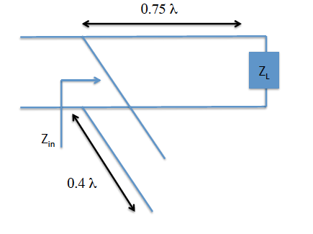

1. Find the normalized input admittance of the load (yL).
2. Find the normalized admittance 0.75 from the load (yin’).
3. Find the normalized admittance of the open-circuited stub (ystub).
4. Find the normalized admittance looking into the combination of the stub, 0.75 of transmission line and the load.
5. Is this a stub tuner? Explain.
6. Design a series stub tuner to match ZL to a 50  line. Use shorted stubs and place the stub close to the load. Specify the location of the stub relative to the load, as well as the length of the stub.
7. Design a shunt stub tuner to match ZL to a 50  line. Use an open circuited stub and place the stub close to the load. Specify the location of the stub relative to the load, as well as the length of the stub.

**Video 2.**

In this video, please demonstrate the steps involved in designing a shunt stub tuner (Question 3, part g).

1. Plot the normalized load impedance, zL.
2. Show the constant s-circle.
3. Plot the normalized load admittance, yL.
4. Show how you determine the location of the stub (i.e. the distance away from the load where the stub is attached).
5. Show how you determine the length of the stub.